This is a report from usability testing sessions conducted during badges hackfest, Flock’19.
We tested with a diverse range of users, some participants use Fedora Badges for a long time and some were newcomers. Although there were, of course, a lot of great features, this report focuses more on the blockers users encountered during the test.
I did not write any recommendations here since we will have a virtual hackfest going on, where we will discuss all these points in detail and see how to improve each issue.

Landing page
The landing page is divided into 3 main sections Latest Awards, Weekly Leaders, Monthly Leaders. All the information here is fitting for this page since it gives information in the overall activity of other contributors but there were some usability issues spotted during the testings.
Issue #1: The badges names are only shown as labels when the user hovers, otherwise there is no other way to know the title of a particular badge. While having labels is a good accessibility feature, there must be a title and textual explanation that is always visible and located near the badge as well.

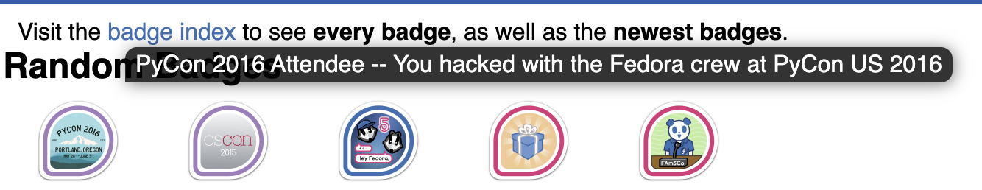
Issue #2: First-time users were confused with the overall concept of badges. They weren’t clear on how do they earn a badge, meaning, do they need to contribute first and then earn a badge or they can aim a certain badge first and then find out how to claim it. It was also not clear to them the total number of badges they can earn and what badges exist. They expected to find a list of all badges where they could get information on what each of them means and how it can be earned.
When they clicked on one of the badges featured on Latest Awards, they were redirected to another page which gave more information on that badge. The information given there was still unclear in most cases. The Badge Info section wasn’t enough descriptive and didn’t give more information on how to earn that badge.

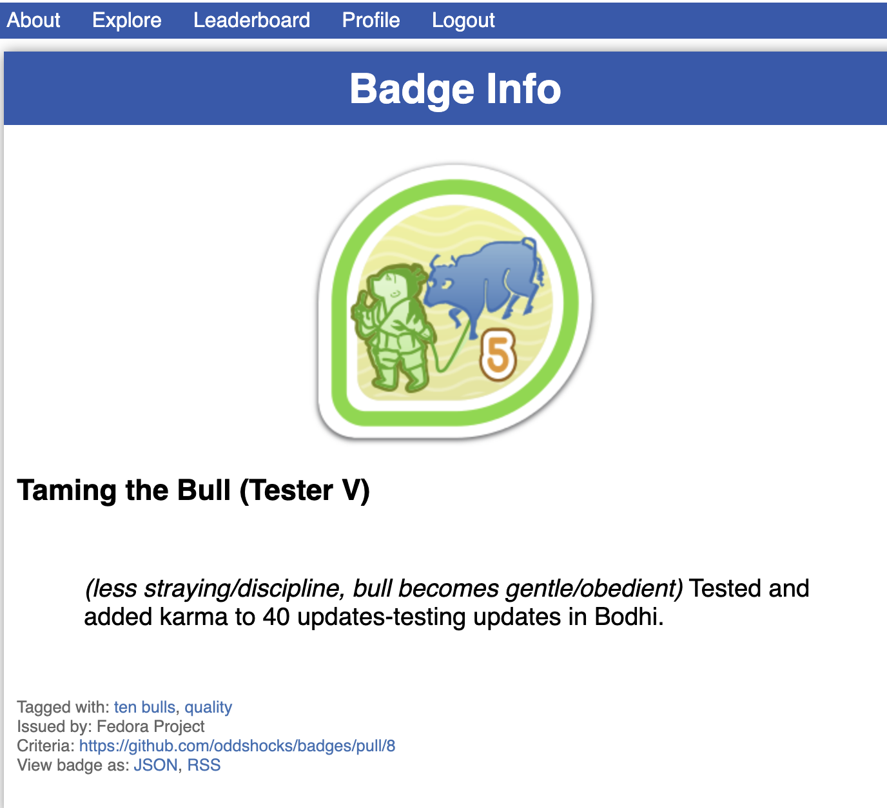

The Badge Holders section was sometimes too crowded and very hard to read.
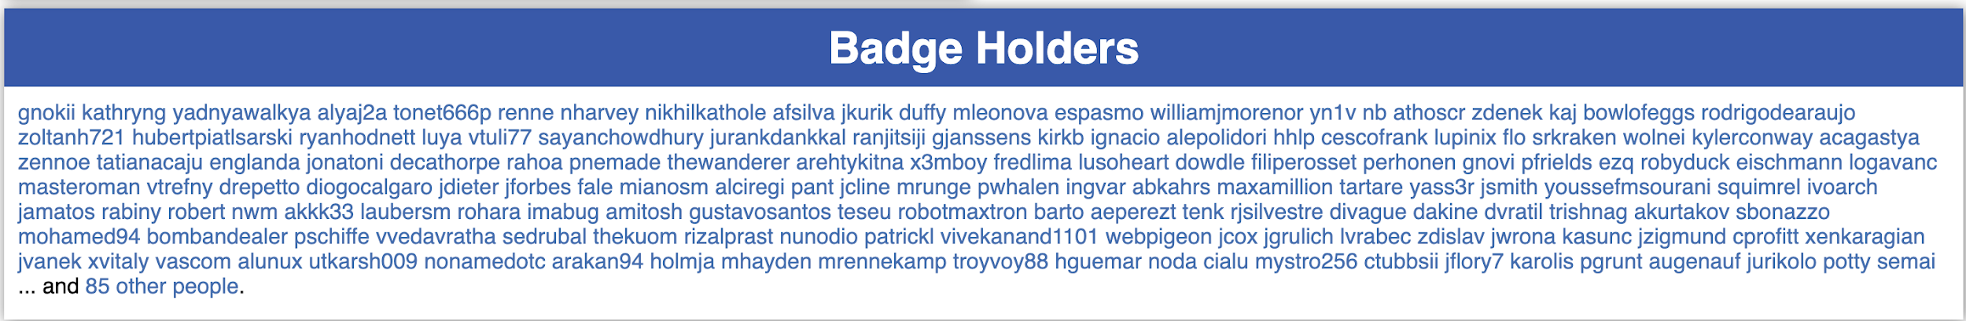
Issue #3: The Latest Awards section is aligned the same as Weekly Leaders and Monthly Leaders. The emphasis on the Latest Award section must be the badges, not the badge holders. We could improve this by simply rearranging the section or using animation to make the badges stand out more.
Issue #4: After exploring the landing page, users didn’t know how to navigate the rest of the site. They didn’t know what’s the next step, how do they find other badges and all the information they were looking for which wasn’t available on the landing page.

The landing page is the first interaction that the user has with Fedora Badges site, therefore it's really important to include the most important information there, to keep the user engaged and lead them to the information they are looking for.

About Page
As users were trying to find more information on badges, they started exploring the navigation bar. They were on doubt if they can find it on About or Explore pages.
The first opinion regarding the About page was that it has too much text and it’s overcrowded. They expected to find more information on the aspect of how to earn them and what badges were available, basically what they didn’t find on the landing page but this information was more about the technical side. Participants expected more infographics and less text.

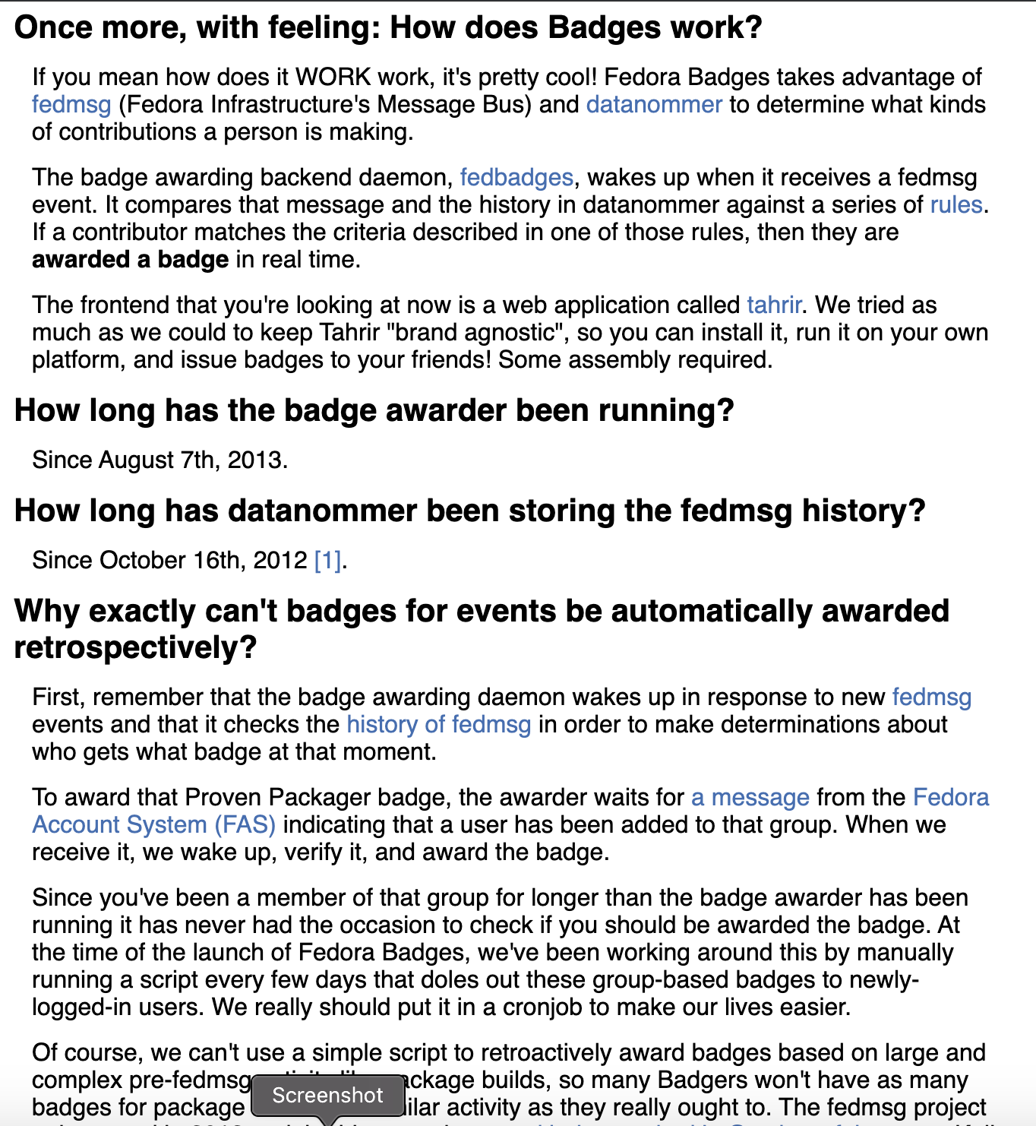

Explore Page
The Explore page is divided into four sections and we tested each of them.
Explore Badges displays a few badges which are randomly picked. Users were still confused about where to find all badges listed. The badge index link is located on the corner it’s not visible enough and the wording is not clear. Users expected something like a link or button named All badges.

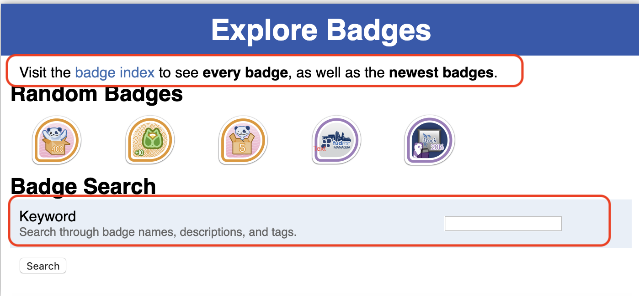

Searching for keywords is a very nice feature but users didn’t know how to search for them. They didn’t know the names of the badges, or their description or their tags. They just tried random words and sometimes guessed them for example Design and then found a long list of badges https://badges.fedoraproject.org/explore they tried clicking on a random badge but there were some badges that were never awarded and the description wasn’t clear, for example, https://badges.fedoraproject.org/badge/m-maybe-design-design-team-ii
The Explore People section was quite understandable. The search results appear on the same page but on a separate section, while the other sections search bar led users to a separate tab where the results were shown, this was a bit confusing.
For example:

The results after searching “design” keyword on Badge search which lead to a separate window of results:
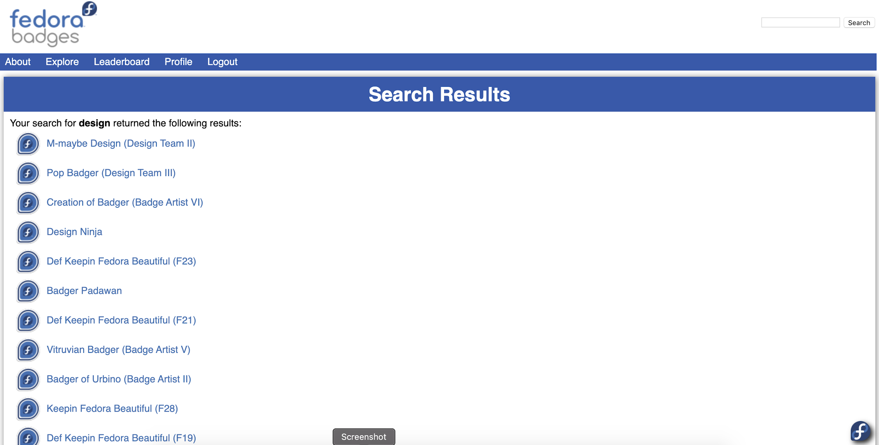

The results for searching “renata” keyword on Person Search which showed the results on the same page:
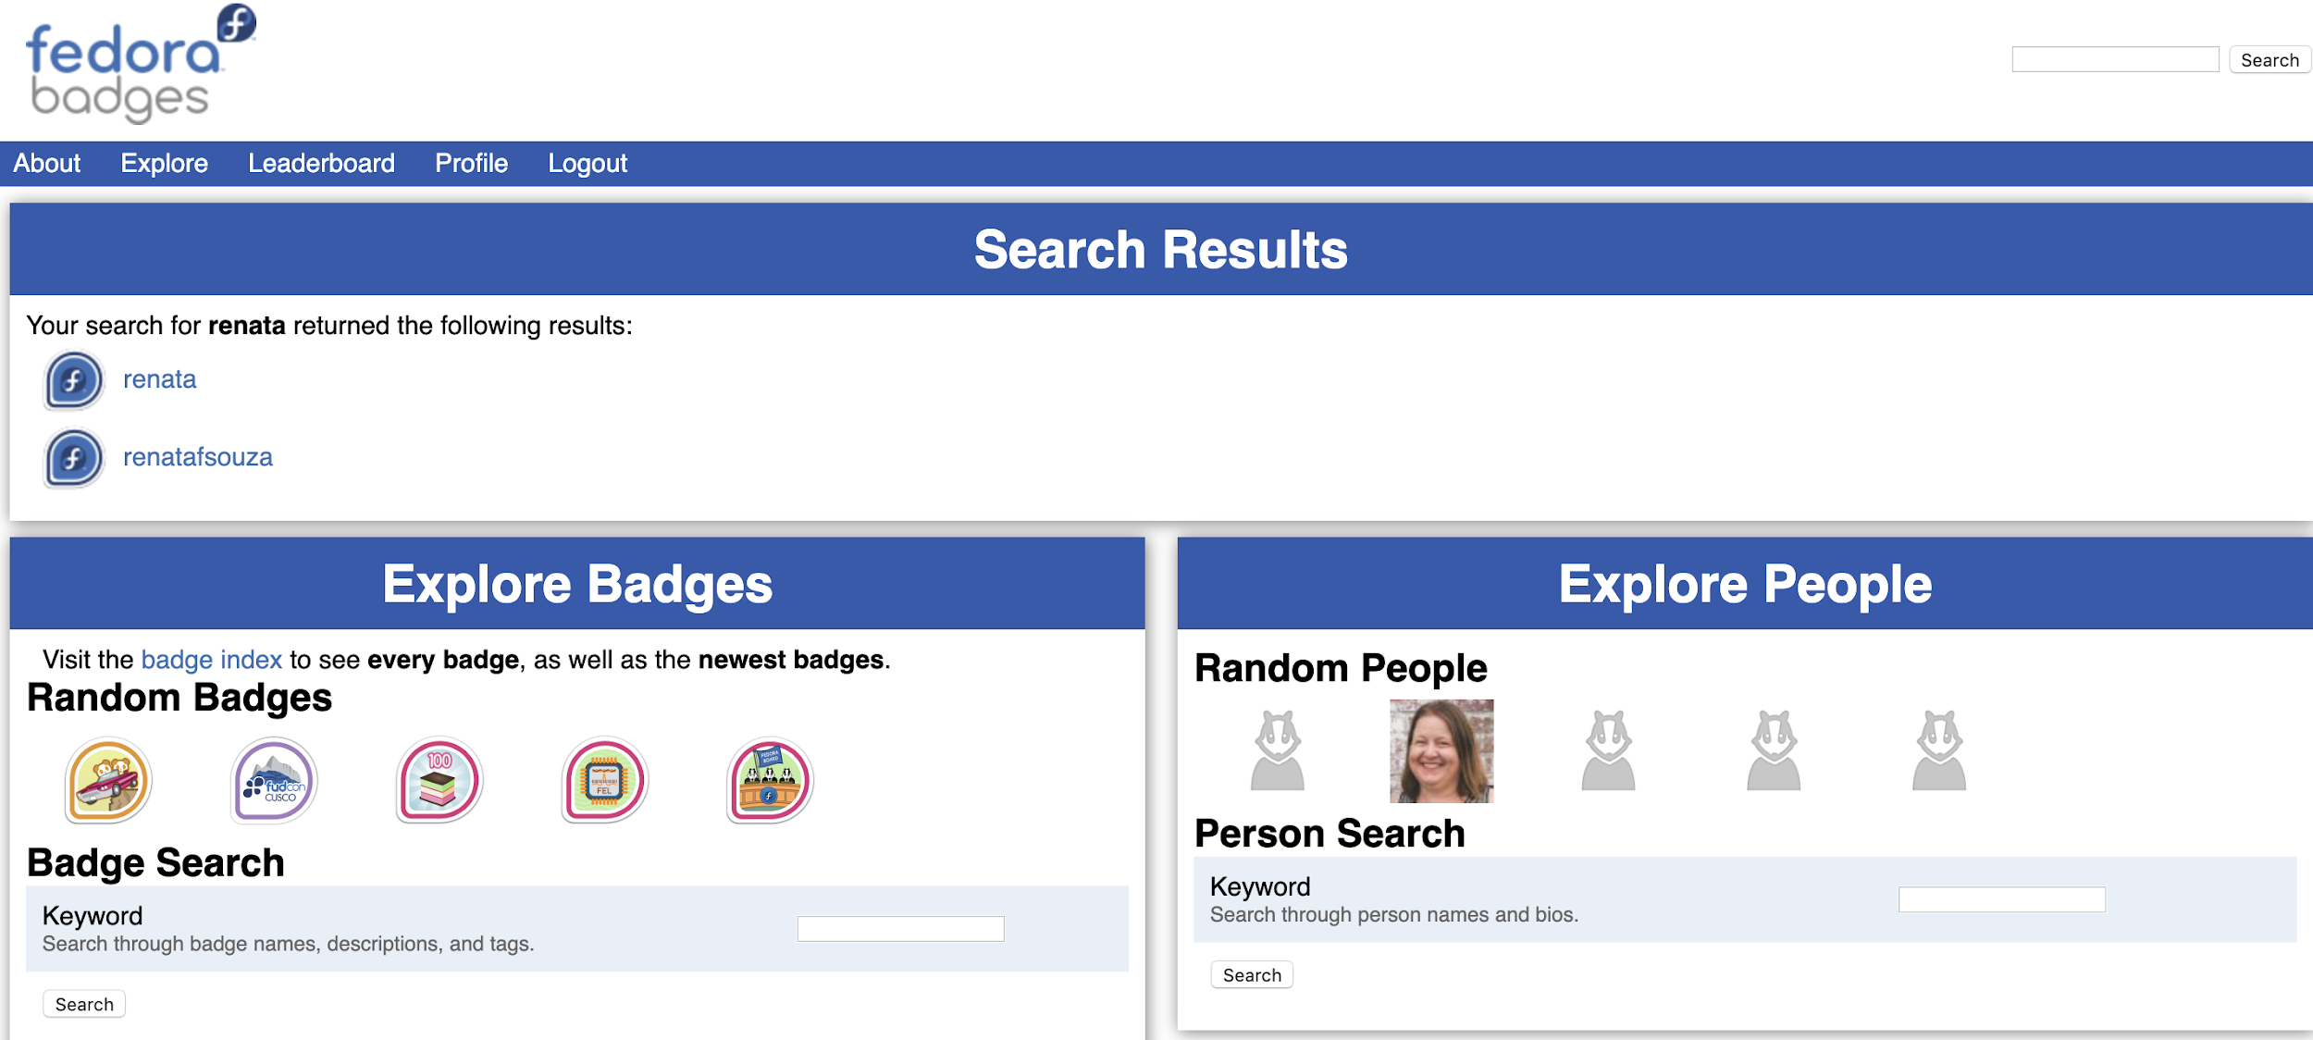

The explore Tags section was also confusing. They weren’t sure how to search for tags but also Match all tags. Participants weren't sure whether to check the box or not and how it affects the search.
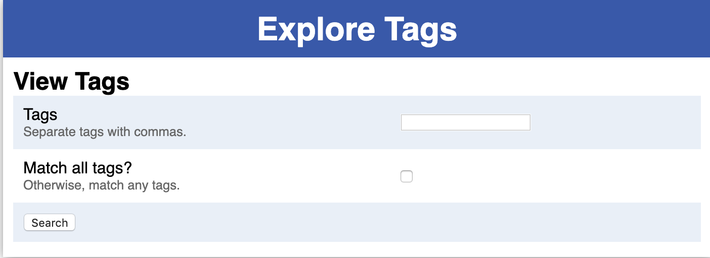
Reports section: “You can construct URLs to generate reports on almost any time frame. Take a look at the following examples” wasn’t understandable and the data included here is outdated.
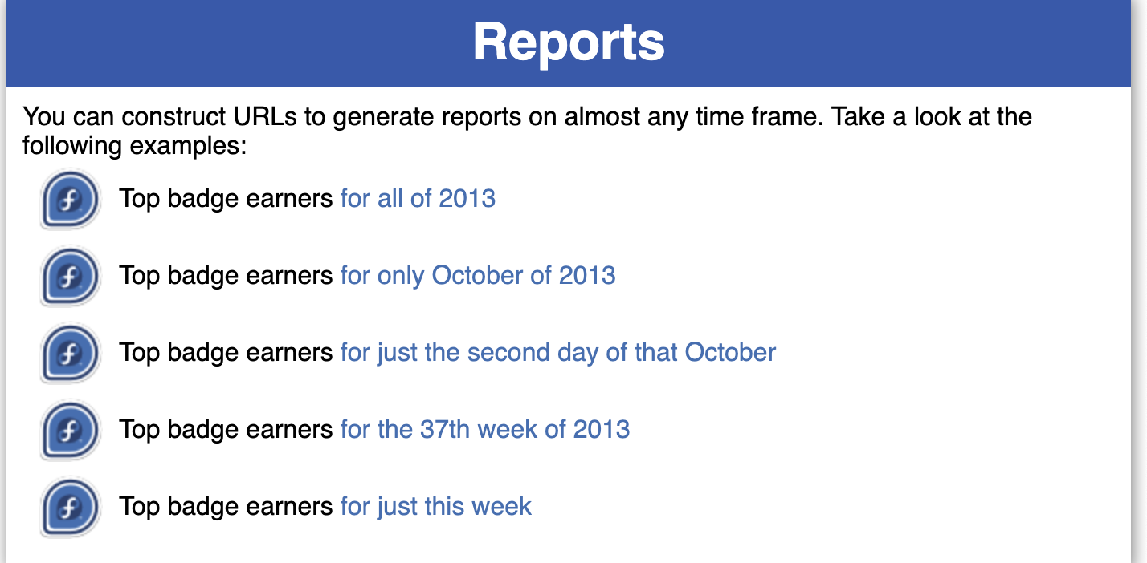

Leaderboard Page
The title on the header that shows the rising stars of the month was often skipped because it seemed too long to read “Rising stars: month of 2019-09-01 to 2019-09-30”
The ordering on the left was also confusing. Users understood that there are (in this example) two #2 places because each contributor has earned the same amount of badges(5 badges each) but they didn’t understand why after #2 the counting jumped to #4.
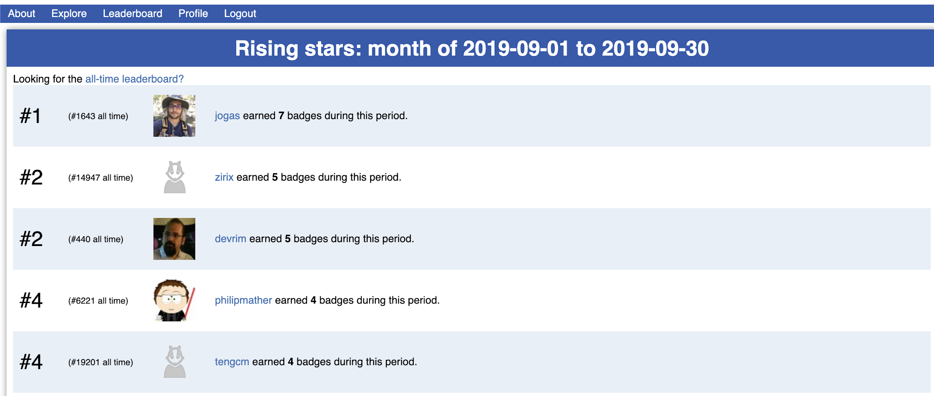

The “All-time leaderboard” link wasn’t obvious enough and some users didn’t notice it.

Profile Page
The “Profile” category was pretty straight forward. The categories are divided nicely and the descriptions were understandable.
The sidebar was also easy to use except some small issues with “Change Avatar” and “Manage Notifications”.
Participants didn’t get the concept of Libvratar and weren’t familiar with Open Id. The process of changing the avatar takes more time than it does usually, even the users who understand it often don’t use it and that’s why most accounts on fedora badges don’t have avatars.
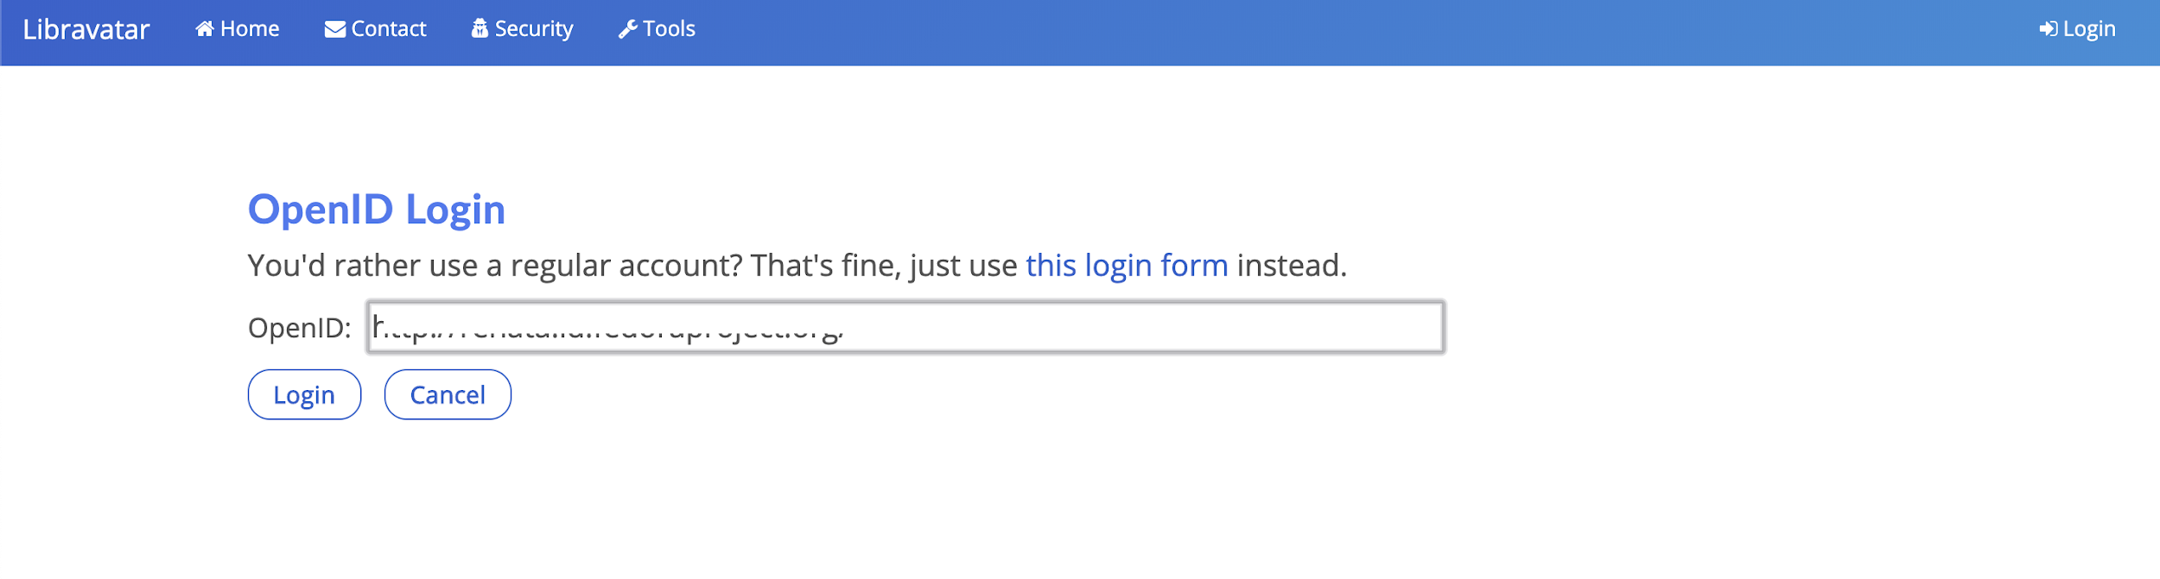

Similar to that, the notifications send the user to another external link which is also confusing. The user is presented with another account which inside the badges account which has similar functionality as their badges account Profile/About/Log out and users where confused, they were wondering if they are still on fedora badges or this is a totally separate account and if they log out here for example would they be logging out from fedora badges or from fedora notifications, why is there a separate account just for notifications?
